1. **GARFIS**

**package grafis;**

**import java.awt.*;**

**public class Grafis extends Panel {**

**Grafis(){**

**setBackground(Color.GRAY);**

**}**

**public void paint(Graphics g) {**

**g.fillRect(0, 250, 290, 50);**

**g.drawLine(125, 250, 125, 160);**

**g.drawLine(175, 250, 175, 160);**

**g.drawArc(85, 157, 130, 50, -65, 312);**

**g.drawArc(85, 87, 130, 50, 62, 58);**

**g.drawLine(85, 177, 181, 89);**

**g.fillArc(78, 120, 40, 40, 63, -174);**

**g.fillOval(120, 96, 30, 40);**

**g.fillArc(173, 100, 40, 40, 110, 180);**

**}**

**public static void main(String[] args) {**

**Frame f = new Frame("Teating Graphics Panel");**

**Grafis gp = new Grafis();**

**f.add(gp);**

**f.setSize(900, 900);**

**f.setVisible(true);**

**}**

**}**

**CODING**

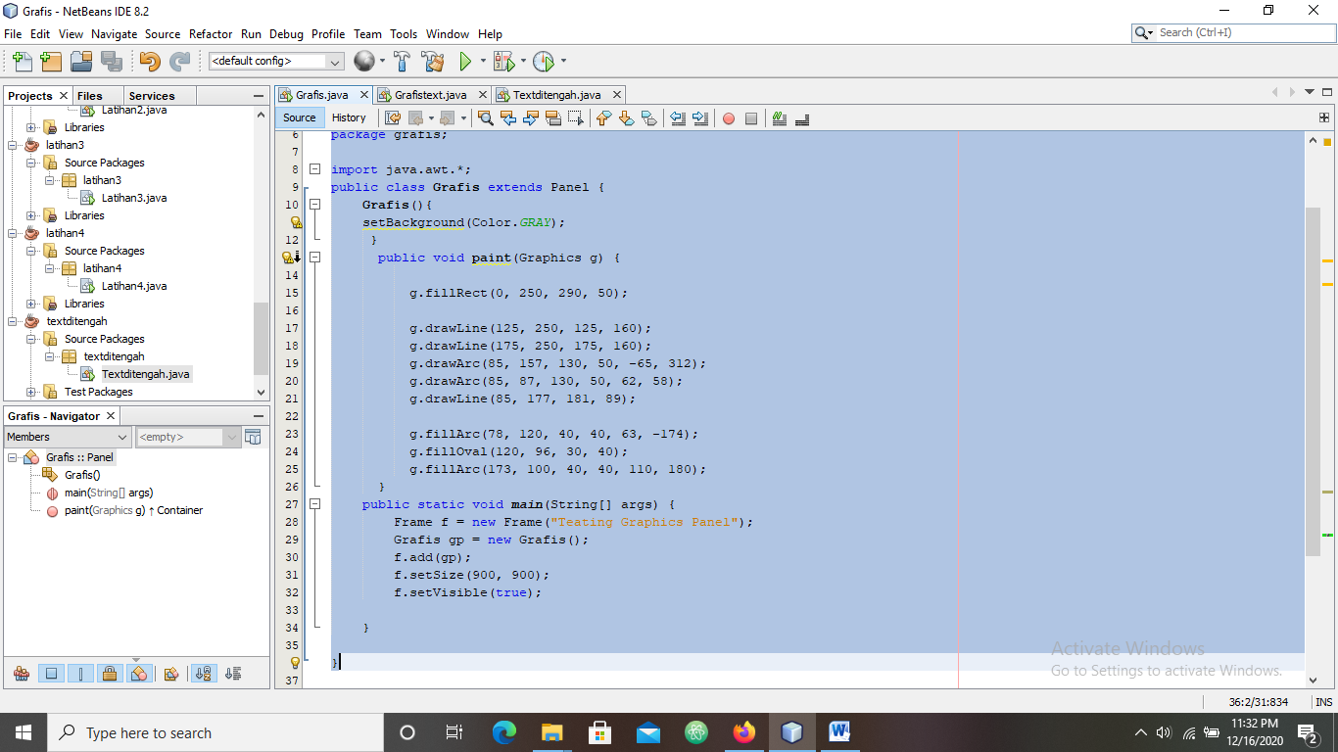

**HASIL RUN**

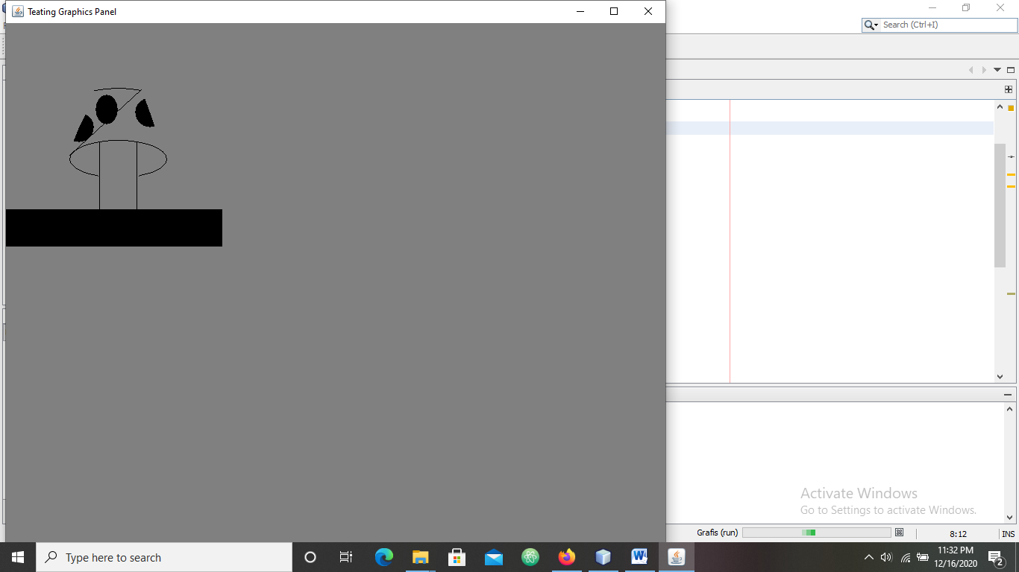

1. **GRAFIS TEXT**

**package grafistext;**

**import java.awt.*;**

**public class Grafistext extends Panel{**

**Font f;**

**String text = "HALO KHARISMA";**

**Grafistext(){**

**setBackground(Color.GRAY);**

**}**

**public void paint(Graphics g) {**

**f = new Font ("Helvetica", Font.BOLD,48);**

**g.setColor(Color.GREEN);**

**g.fillRect(8, 8, 450, 105);**

**g.setColor(Color.BLACK);**

**g.drawRect(8, 8, 450, 105);**

**g.setColor(Color.PINK);**

**g.fillOval(10, 10, 450, 100);**

**g.setColor(Color.RED);**

**g.drawOval(10, 10, 450, 100);**

**g.drawOval(9, 9, 450, 102);**

**g.drawOval(9, 9, 450, 104);**

**g.setColor(Color.BLACK);**

**g.setFont(f);**

**g.drawString(text, 40, 75);**

**}**

**/\*\***

**\* @param args the command line arguments**

**\*/**

**public static void main(String[] args) {**

**Frame f = new Frame("Testing Graphics Panel");**

**Grafistext gp = new Grafistext();**

**f.add(gp);**

**f.setSize(900, 900);**

**f.setVisible(true);**

**// TODO code application logic here**

**}**

**}**

**CODING**

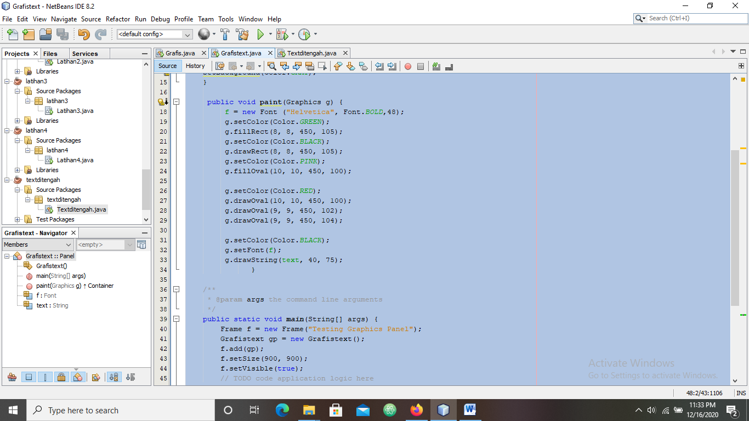

**HASIL RUN**

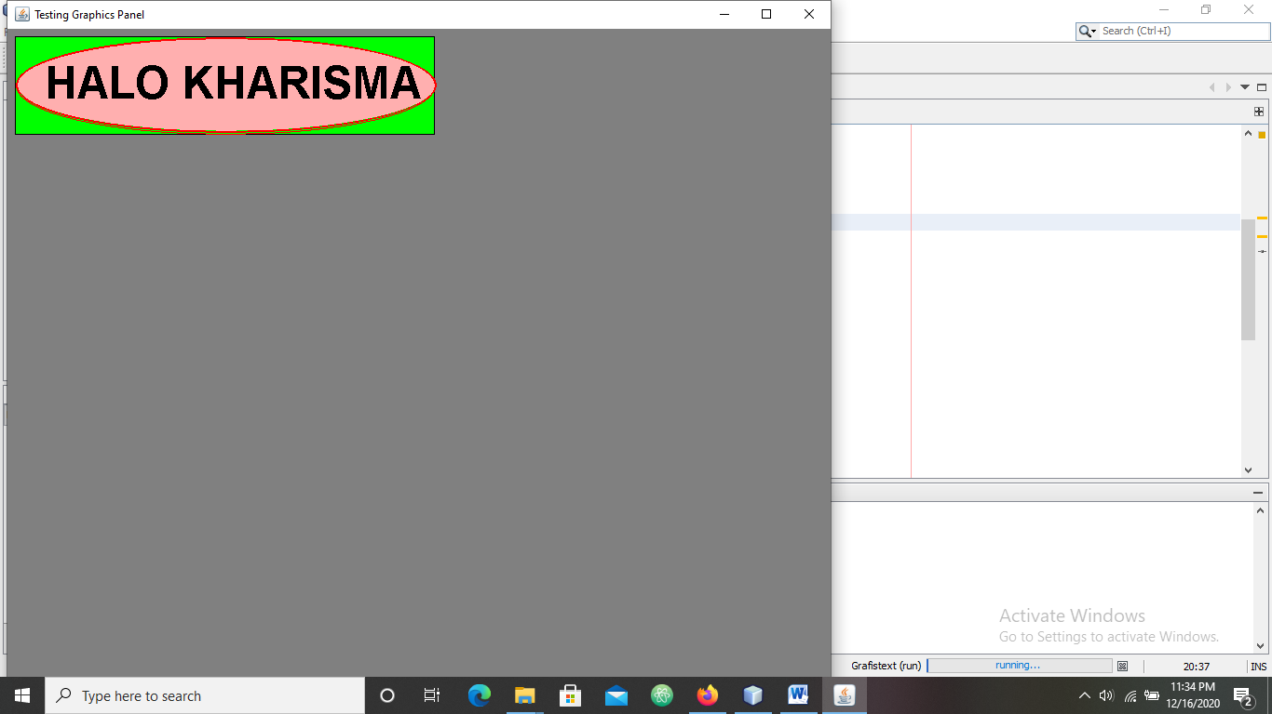

1. **TEXT DI TENGAH**

**package textditengah;**

**import java.awt.Color;**

**import java.awt.Font;**

**import java.awt.Graphics;**

**import java.awt.FontMetrics;**

**import java.awt.Frame;**

**import java.awt.Panel;**

**public class Textditengah extends Panel{**

**Textditengah(){**

**setBackground(Color.PINK);**

**}**

**public void paint(Graphics g){**

**Font f = new Font ("Helvetica", Font.BOLD,48);**

**FontMetrics fm = getFontMetrics(f);**

**g.setFont(f);**

**String S = "teks ini tampil ditengah - HEEEYY YUUUUUU";**

**int xpos = (this.size().width - fm.stringWidth(S)) / 2;**

**int ypos = (this.size().height) / 2;**

**g.drawString(S, xpos, ypos);**

**}**

**public static void main(String[] args) {**

**Frame f = new Frame ("Testing Graphics Panel");**

**Textditengah gp = new Textditengah();**

**f.add(gp);**

**f.setSize(600, 300);**

**f.setVisible(true);**

**}**

**}**

**CODING**

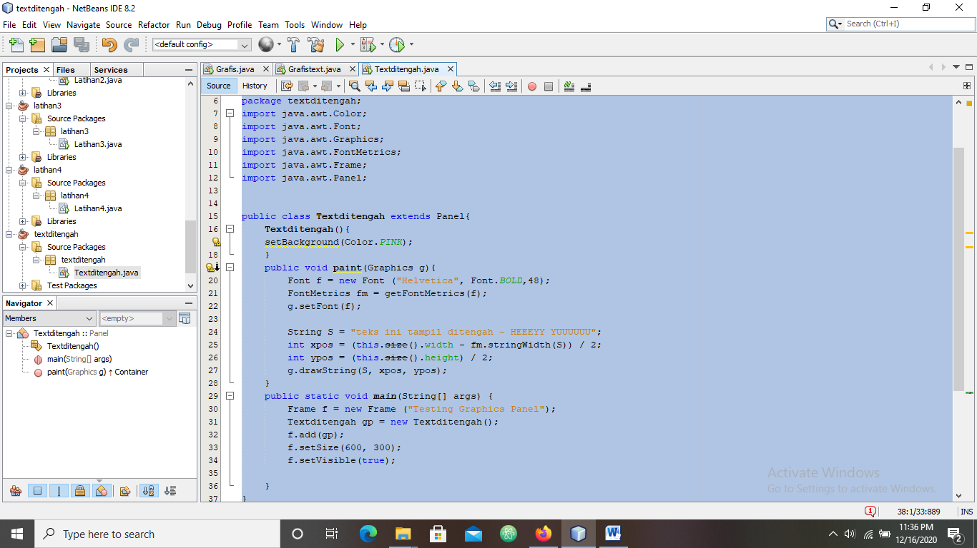

**HASIL RUN**

